How to Login Microsoft Office 365
- Sign in your email, (for student insert your ID student) for example :
123456@student.dhu.edu.my
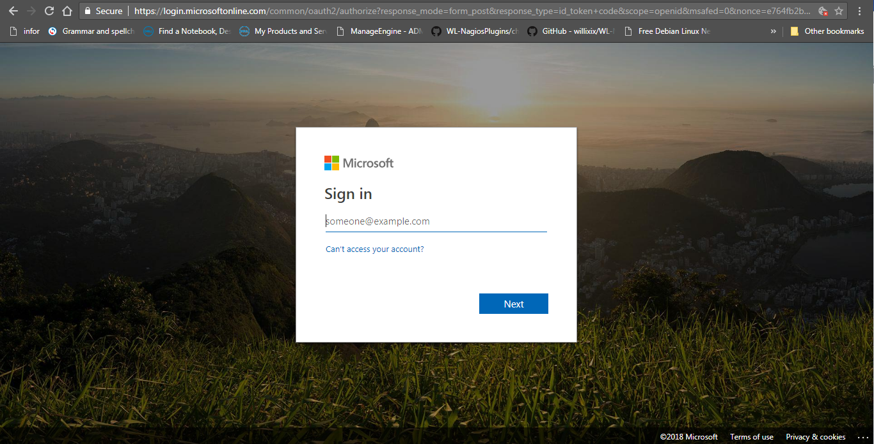
- Insert your same password for Wi-Fi connection.
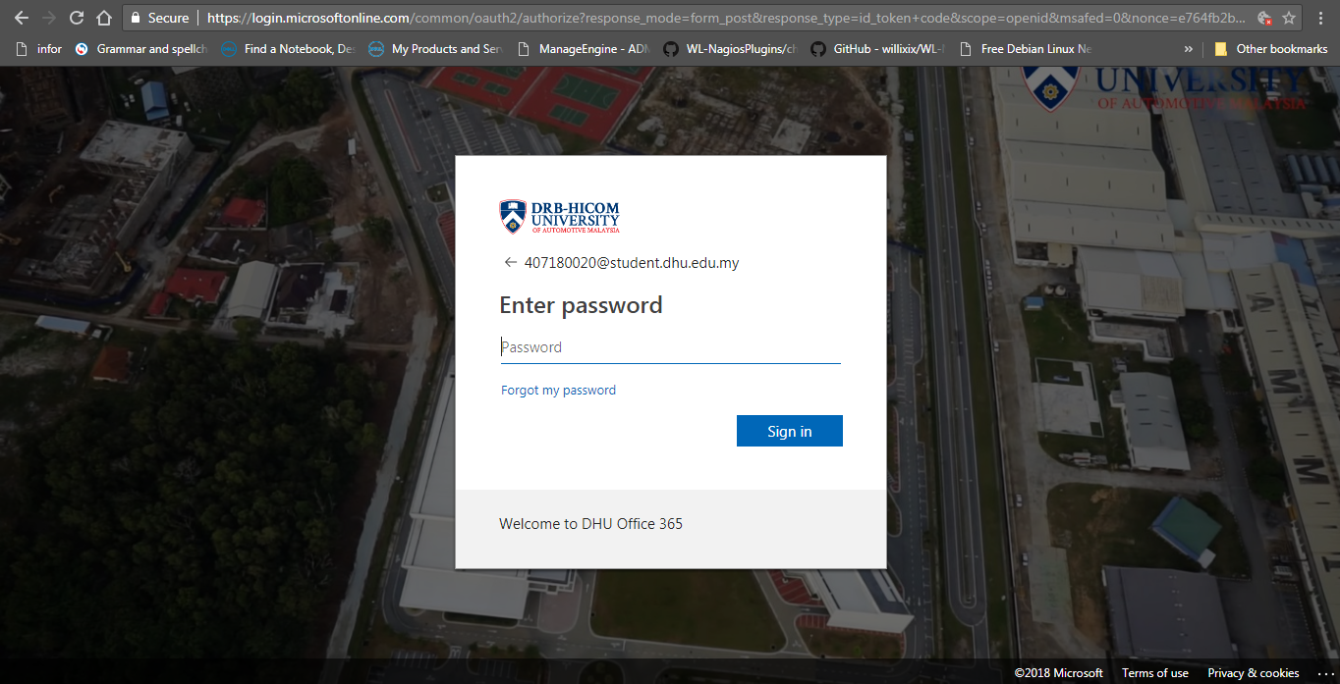

- Tick ‘Don’t show this again’ and click ‘Yes’
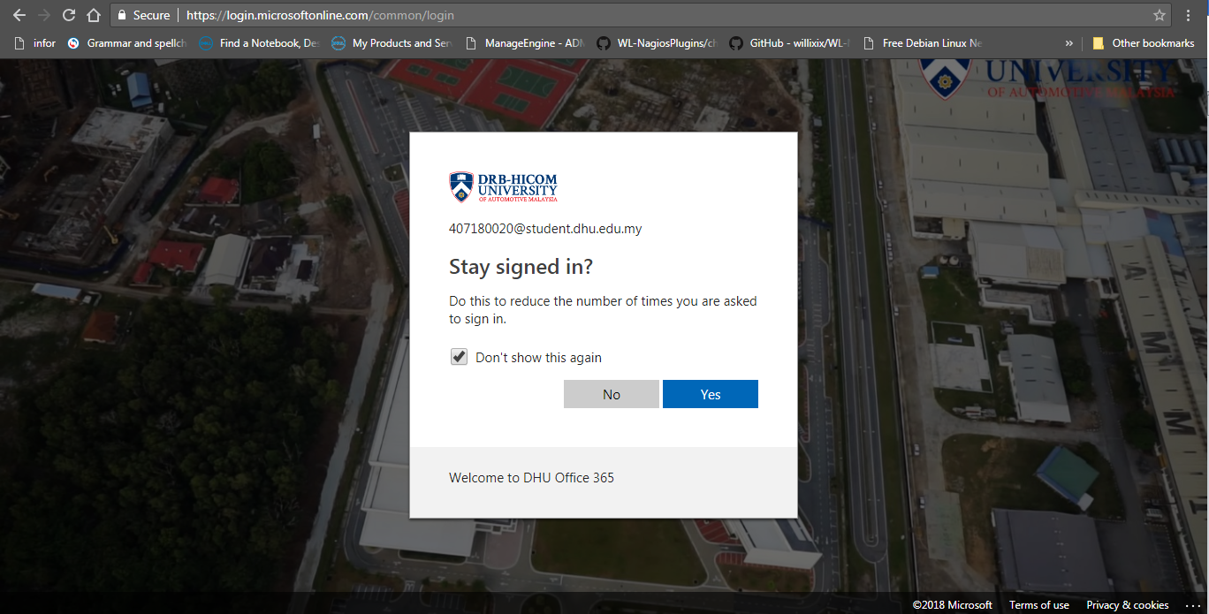
- Kindly to complete this form for join the MYREN training.
